Week 8 – Guide of Labs / Workshops

W8-01 Google PaLM Gemini MakeSuite

Go to and read:
https://developers.googleblog.com/en/make-with-makersuite-part-1-an-introduction/

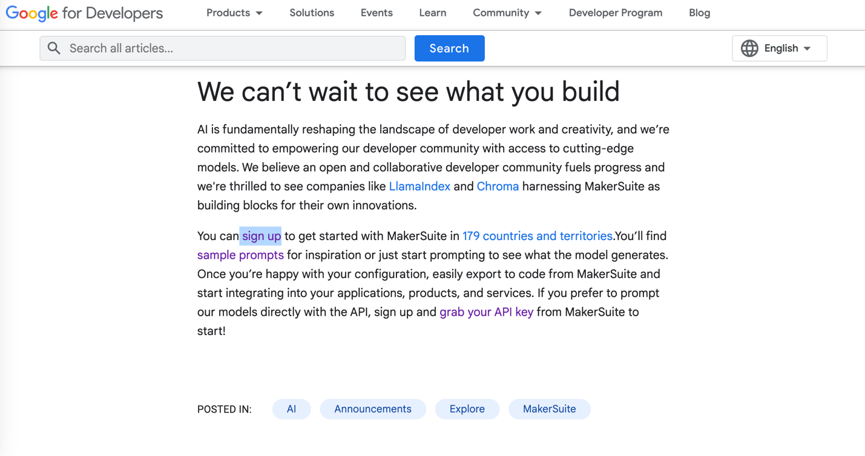

At bottom of above page, click 'sign up'. Then Google AI Studio will show, like below.

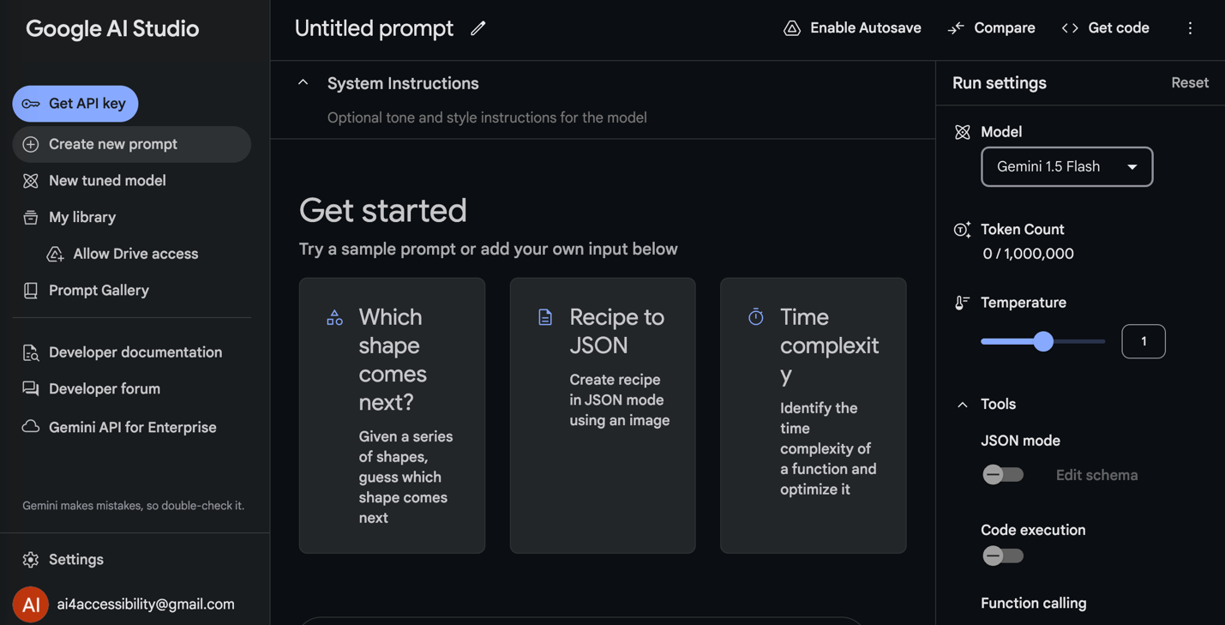
In the above, upper right corner, click <> Get code

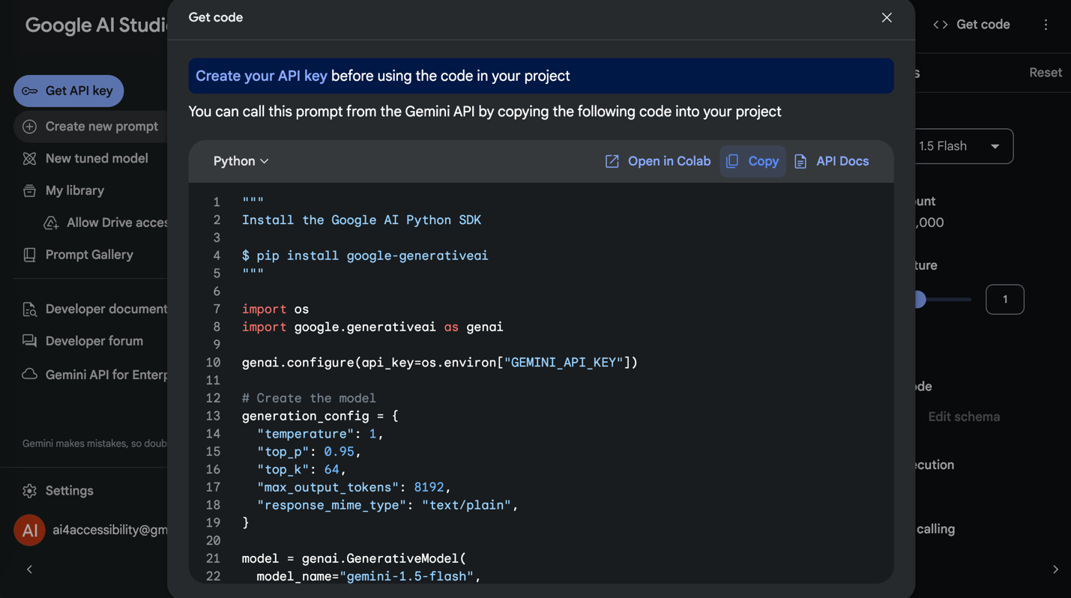
In the above, choose Copy (or Open in Colab), then paste the code into a newly created Google Colab notebook of yours own.
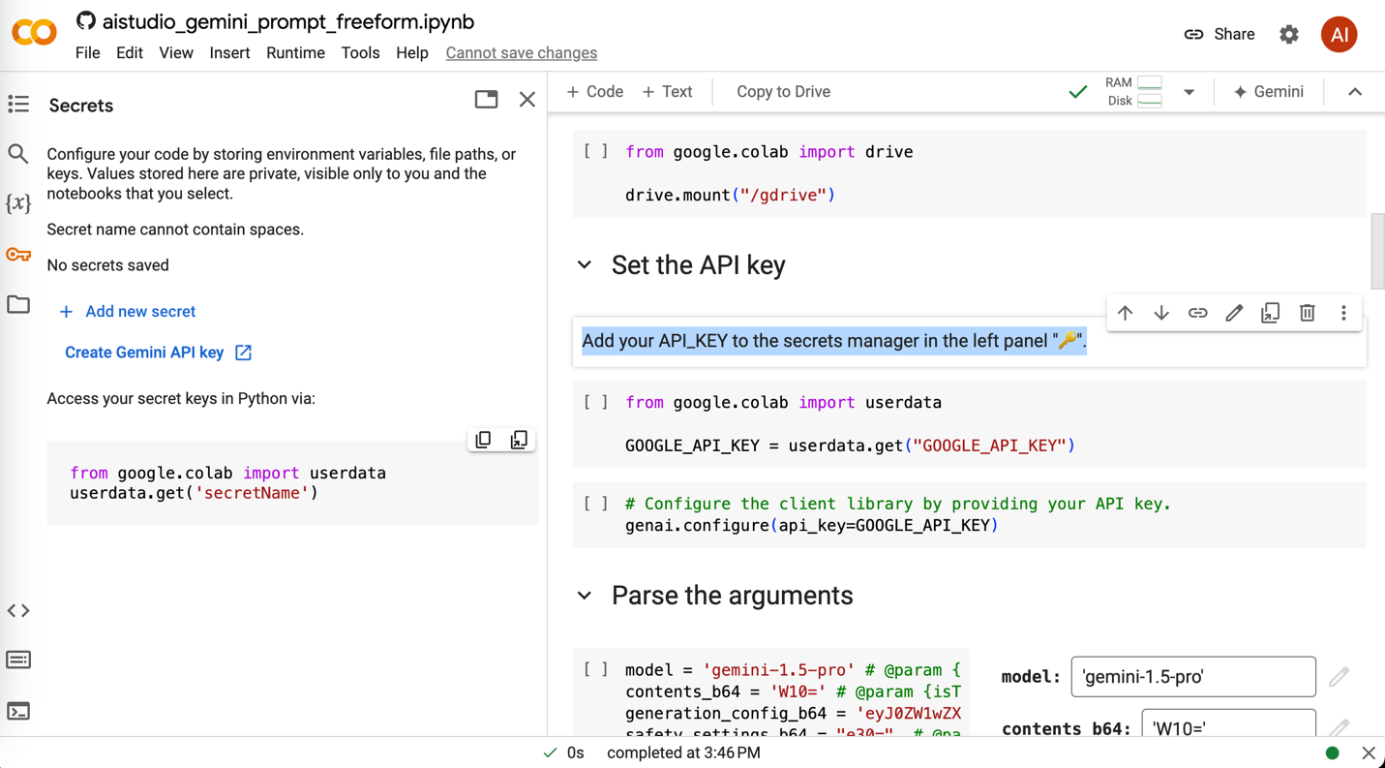
Follow notebook and setup API keys, please take note of the API key name, e.g., I used GOOGLE_API_KEY. Enable the ‘Notebook access’ blue button shown below.

After API setup, update highlighted code below to read in API key in the new method.
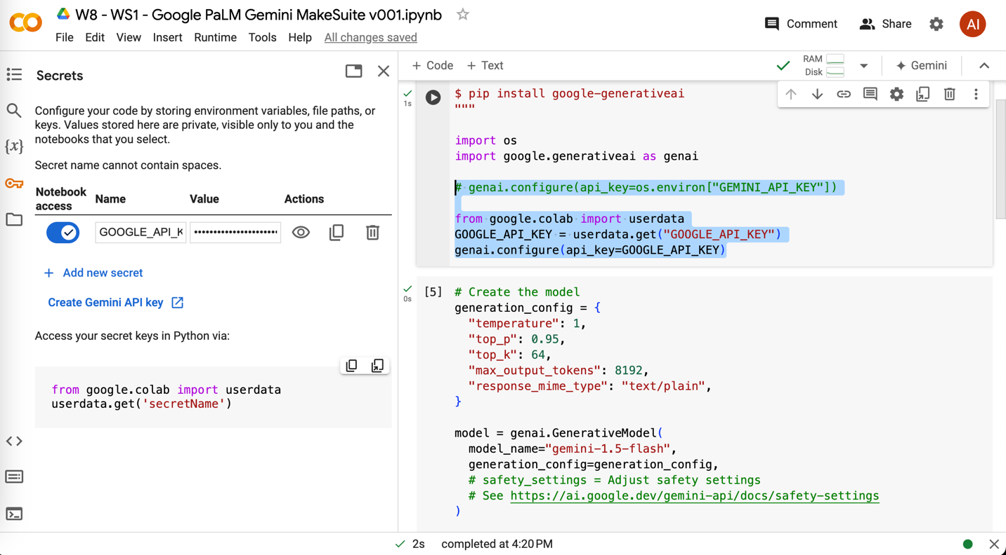

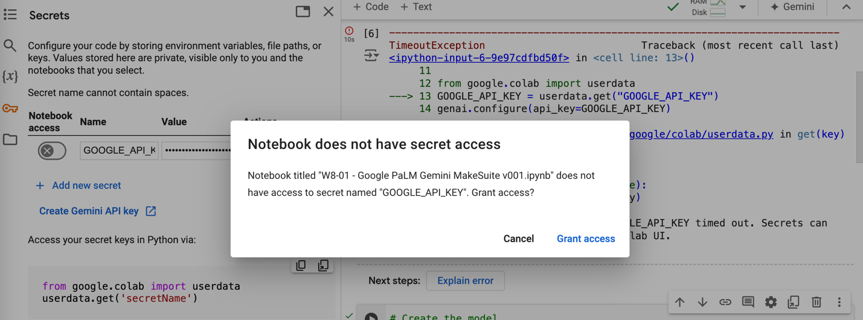
Above shows when the ‘Notebook access’ is not enabled.

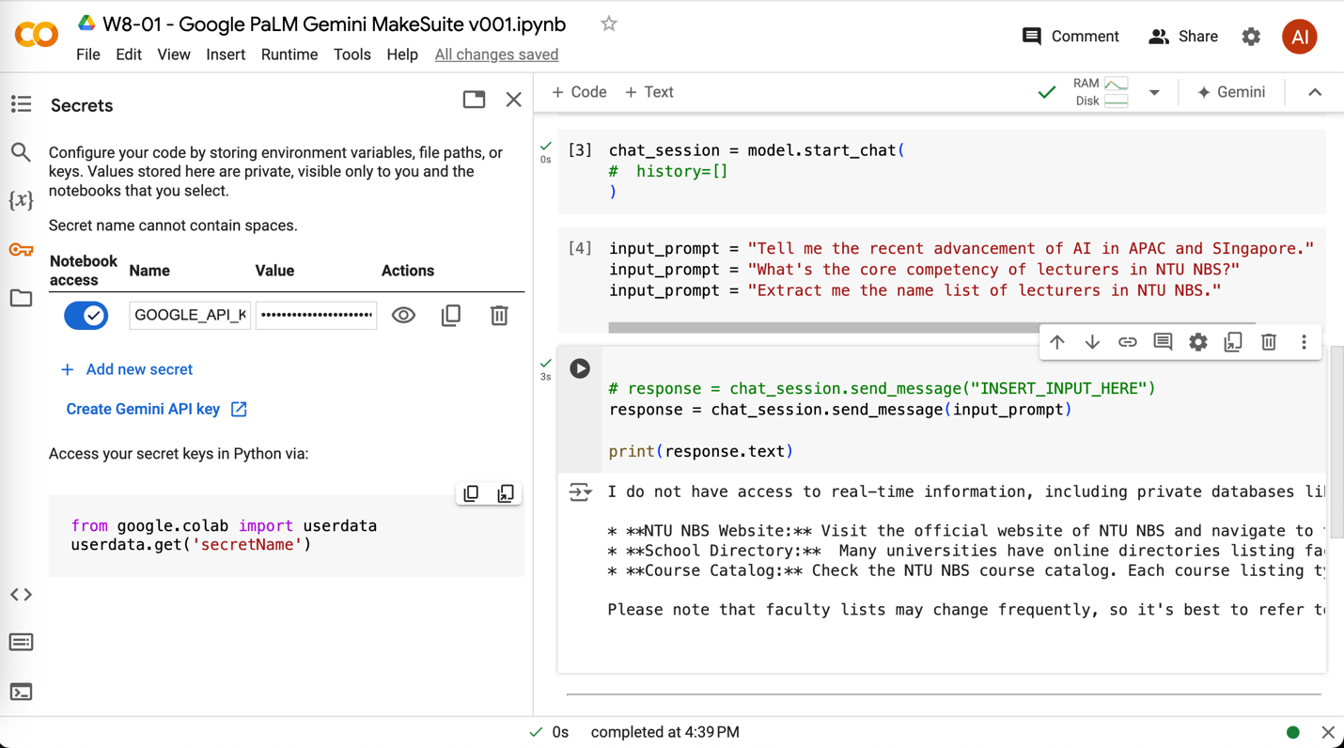
In the above, experiment more creative input_prompt of yours.

W8-02 Replicate Image Generator [Optional lab due to fee]

Replicate.com seems to require billing using credit card now. No so free to use.
